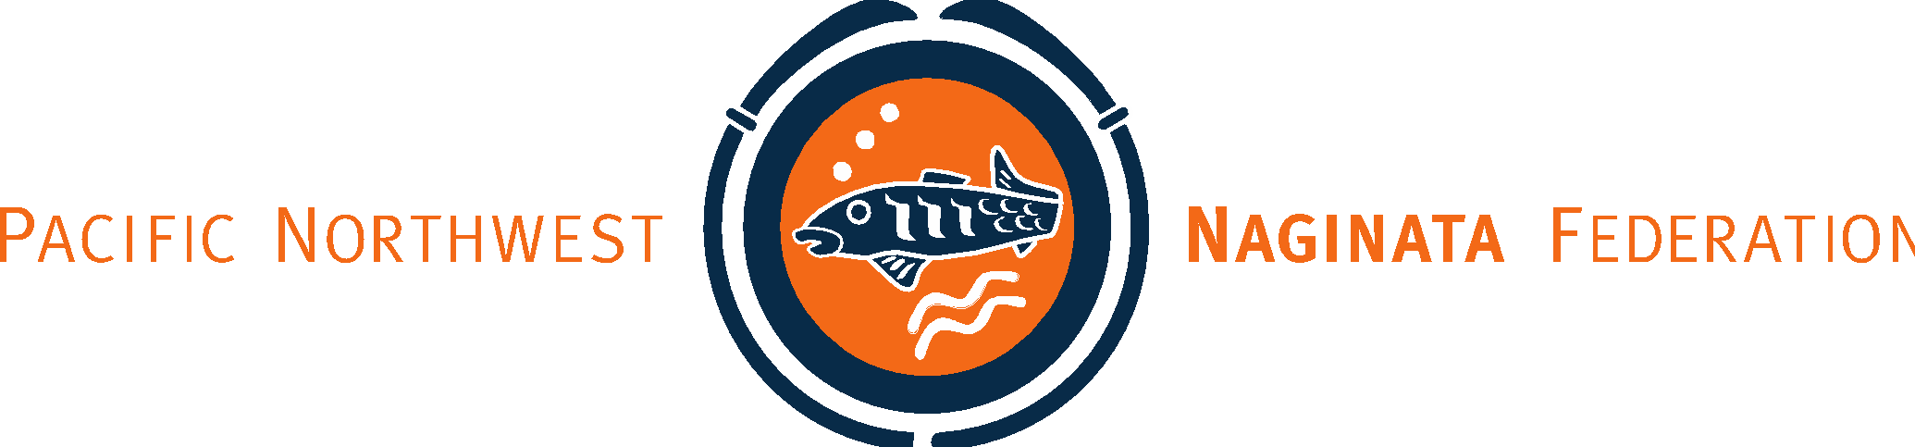

2023 PNNF Tendo Ryu Seminar Registration

Seminar (Saturday, April 22 and Sunday, April 23, 2023)

Name | 4/22 | 4/23 | Sat  Lunch  Y/N | Sun  Lunch Y/N | Naginata Level | Tachi Level | Jo/Tanto/  Kusarigama
Name |  |  |  |  | (i.e., Shodan) | N/A | N/A
Example 1 | X | X | Y | Y | Omote no Oku | Omote | All
Example 2 | X | X | Y | Y | Omote | Ura | Jo
Example 3 |  | X |  | Y | Ura (partial) | N/A | N/A

Seminar Fees

Categories | Total No. |  | Price | Fee
1-day Bitokukai member |  | X | $75.00 | $
2-day Bitokukai member |  | X | $100.00 | $
1-day non-Bitokukai member |  | X | $90.00 | $
2-day non-Bitokukai member |  | X | $120.00 | $
Saturday lunch * |  | X | Sandwich $10 | $
 |  |  | Sandwich $11  Salad $11 | $
Sunday lunch* |  | X | Sandwich $10 | $
 |  |  | Sandwich $11  Salad $11 | $

Participant Fee Total: $

Lunch Choices

Sandwiches | Sat. | Sun. |  | Price | Fee
Turkey Breast & Swiss |  |  | X | $10 | $
Smoked Ham, Swiss |  |  | X | $10 | $
Chicken Club (Grilled chicken, bacon, cheddar) |  |  | X | $11 | $
Mediterranean (Veggie)(hummus and feta cheese, artichoke hearts, cucumbers and roasted red peppers on multigrain bread) |  |  | X | $11 | $
Salads |  |  |  | Price | Fee
Powerhouse (with Chicken, avocado, hummus, boiled egg, cucumber, tomato, lettuce, non-fat vinaigrette) |  |  | X | $11 | $
Farmhouse (Chicken, bacon, blue cheese, boiled egg, grape tomatoes, onion, buttermilk ranch) |  |  | X | $11 | $
Chicken Salad (Chicken salad, provolone, cranberries, cucumber, tomatoes, field greens, balsamic) |  |  | X | $11 | $

Please indicate choice of condiments or other notes. | Please indicate any dietary restrictions or allergies.

PNNF will supply chips, cookies, water, and some snacks. Participants can also bring a reusable water bottle.

